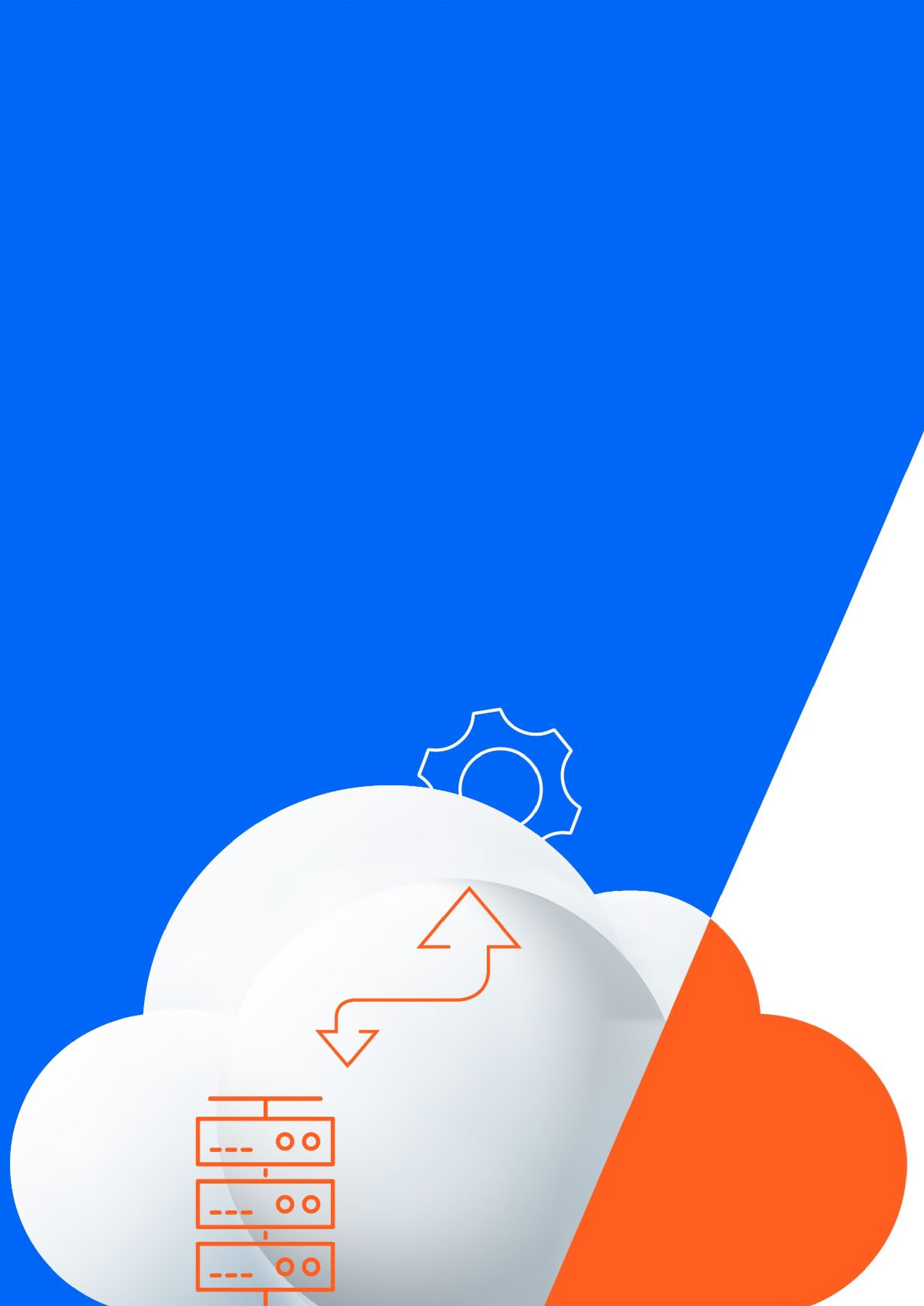

**How to Simplify**

**Network Operations with**

**DriveNets Network Cloud**

Frequently Asked Questions



**DriveNets Builds Networks like Cloud**

DriveNets is a fast-growing software company that builds networks like clouds. By aligning network growth and costs, DriveNets helps service providers build networks more profitably. DriveNets Network Cloud is a proven carrier-grade solution that has been deployed in many tier-1 carriers around the world. AT&T’s core network – the largest backbone network in the United States – a significant (and growing) percentage of traffic runs on DriveNets Network Cloud.

**DriveNets Network Cloud: Cloud-native, Software-based, Shared Infrastructure**

Network technology and economics have been revolutionized by DriveNets Network Cloud.

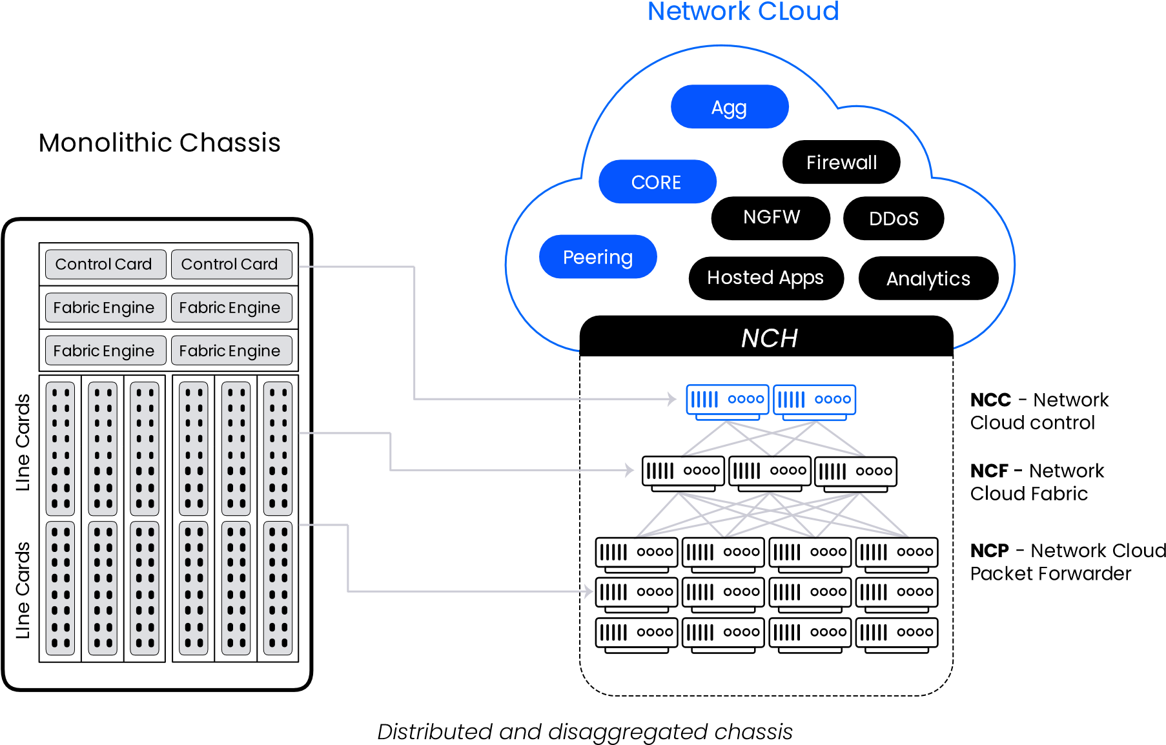

Unlike traditional routing solutions, DriveNets Network Cloud is a cloud-native, software-based solution that supports multiple networks and services over a shared infrastructure with the highest capacity and scale, along with rapid innovation.

Meet increasing service demands much more efficiently, DriveNets Network Cloud can run as a single stand-alone solution in a single white box of 4Tbps or on a cluster of multiple white boxes interconnected as one router using Clos topology. Orchestrated as a cluster of virtually unlimited network and compute resources, service providers can scale up to a large cluster of 691.2Tbps, made up of dozens of white boxes operating as a single routing entity.

DriveNets Network Cloud disaggregates today’s hardware-based routers into building blocks. The control plane runs on x86 servers, and the data plane is implemented in a cluster of white boxes. There are two building blocks in the data plane: Network Cloud Packet Forwarder (NCP) and Network Cloud Fabric (NCF). DriveNets Network Cloud

The solution’s cloud-native software allows for additional services that run in separate software containers. Each networking function, which runs as a service instance (SI) microservice in a cloud container, can utilize any underlying hardware resource, including physical interfaces, NPUs, CPUs, TCAMs, etc .

Frequently Asked Questions

1. How can DriveNets Network Cloud simplify network planning? 4

2. Who is responsible for mitigating failures and solution certification– DriveNets or the chosen hardware vendor? 4

3. Which management interfaces and protocols are supported by DriveNets Network Cloud? 4

4. Can DriveNets Network Cloud integrate with legacy network monitoring and analytics? 5

5. How does DriveNets Network Cloud provide new visibility into network performance? 5

6. Are other vendors' legacy networking equipment compatible with DriveNets? 6

7. How does DriveNets manage the cable “spaghetti mess”? 6

8. What happens if the wrong fiber cable is pulled either accidentally or intentionally? 7

9. How does DriveNets Network Cloud address future scalability challenges? 7

10. Does DriveNets Network Cloud require forklift replacement? 8

11. How does DriveNets Network Cloud help with physical site planning? 8

12. Is it possible to combine 1G-400G and later 800G interfaces in the same router? 11

13. How does DriveNets Network Cloud help simplify the procurement process? 11

# How can DriveNets Network Cloud simplify network planning?

Network planning can be cumbersome and take months. Planning time is heavily impacted by the number of components, service requirements, capacity forecasting, site constraints and more. While integrated chassis solutions are limited in their abilities to simplify the overall process, DriveNets Network Cloud delivers:

* One design process and ease of expansion: DriveNets Network Cloud relies on only two standard data plane building blocks (NCP and NCF), as compared to five to ten integrated router solutions with multiple line card models. With DriveNets, the same NCP and NCF can be deployed across all network domains. Network Cloud is easy to install and cost-efficient, enabling scalable growth capacity, while the chassis model requires full system expansion .
* Modular design: DriveNets Network Cloud reduces costs that directly impact the financial model’s impact on a service provider user organization, where internal organizations only pay for modules and not for the full chassis.
* Better management and reporting: With DriveNets Network Orchestrator (DNOR), it is simple to monitor, plan and optimize network capacity through enhanced visibility and easy APIbased automation.

# Who is responsible for mitigating failures and solution certification– DriveNets or the chosen hardware vendor?

One perceived disadvantage of disaggregated networking architectures is that receiving technical support can be difficult. A multi-vendor solution (one or more for software, one or more for hardware) may lead to a “blame game” between vendors regarding a root-cause analysis. When this happens, it can become extremely difficult to solve the issue at hand.

DriveNets Network Cloud can support any responsibility model required by the service provider. DriveNets can take end-to-end responsibility for the solution certification and service, where any issue (software or hardware) will be subject to DriveNets’ SLA. Alternatively, if required by the service provider, a shared responsibility model can be implemented where the service provider takes the lead on hardware issues.

With DriveNets, service providers can benefit from the multi-vendor model and eliminate any responsibility/certification concerns.

# Which management interfaces and protocols are supported by DriveNets Network Cloud?

DriveNets Network Cloud is designed to support both open and conservative management approaches. The solution can be integrated simply with existing infrastructure and gives service providers the flexibility to choose their preferred management approach.

A DriveNets Network Cloud cluster operates as a single routing entity and can be operated using one command-line interface (CLI). This is enabled by using a familiar management environment and adding a wide range of rich open interface standards, protocols, and data modules to optimize integration and maintenance.

The main interfaces, protocols, and tools supported by DriveNets Network Cloud are shown in the following diagram:

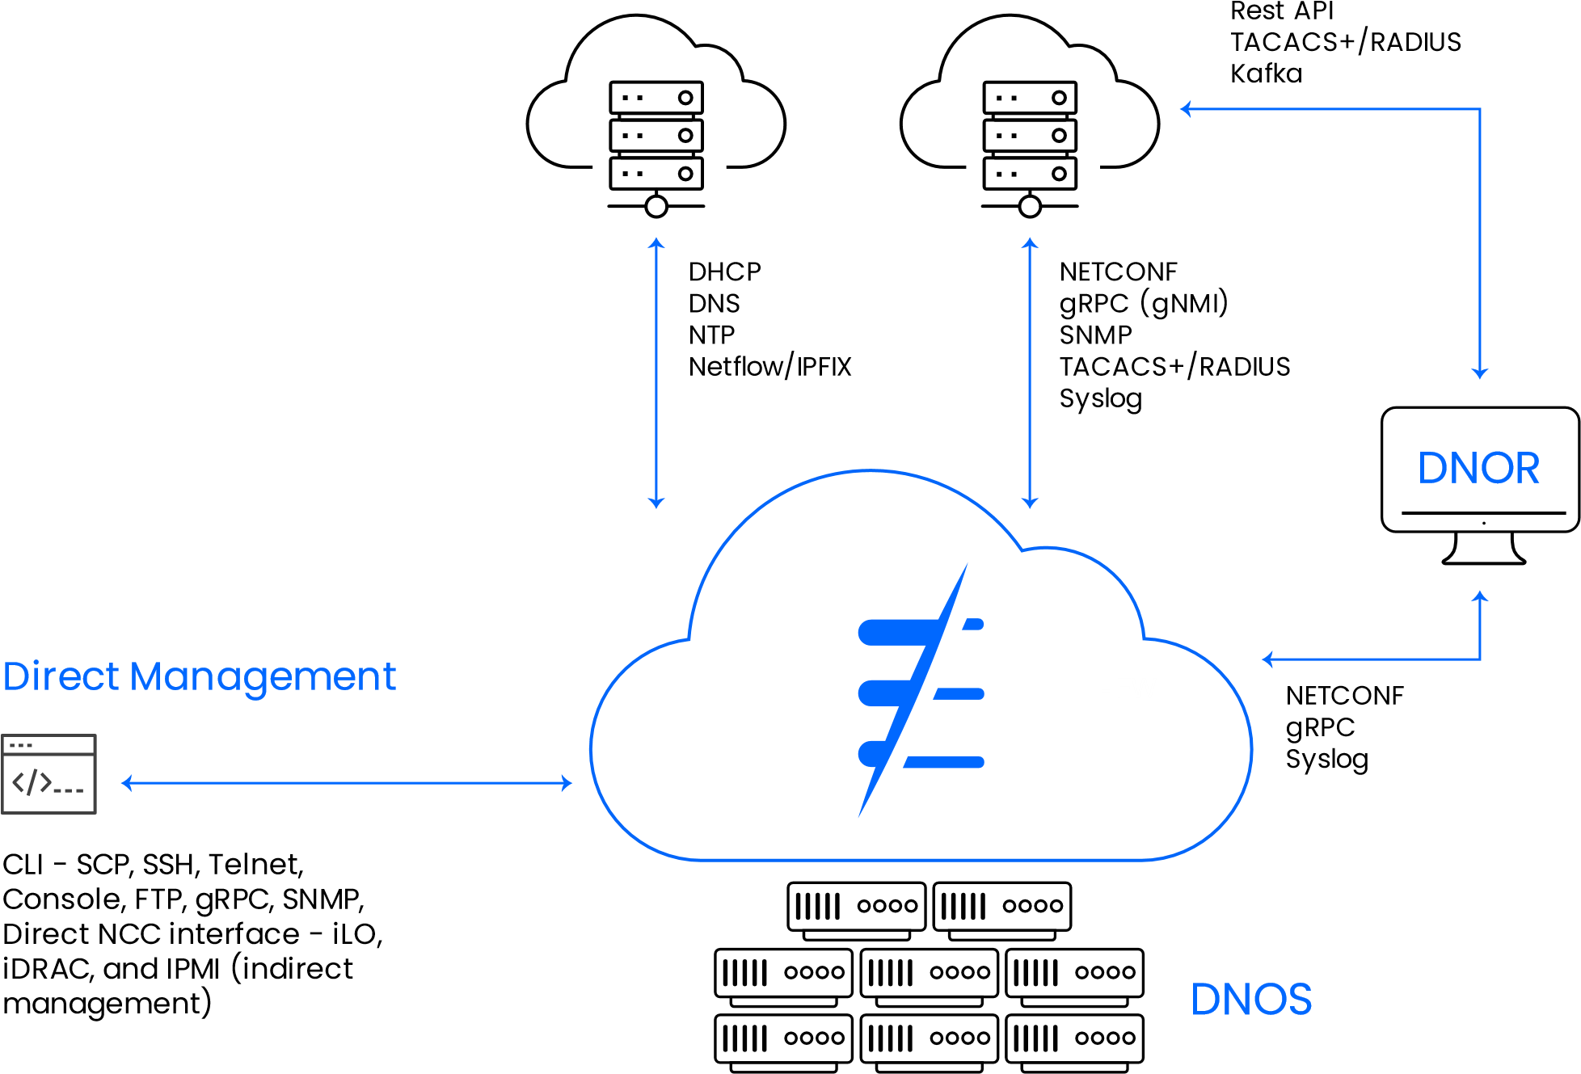

# Can DriveNets Network Cloud integrate with legacy network monitoring and analytics?

Implementing new technology and architecture from a new vendor can be challenging. Service providers can connect to DriveNets Network Cloud using a wide range of open northbound interface standards, protocols, and data modules (such as gRPC/gNMI, NETCONF/YANG, and more). This enables faster integration with existing and future OSS/BSS systems.

# How does DriveNets Network Cloud provide new visibility into network performance?

DriveNets Network Cloud creates network functions by utilizing a cluster of white boxes. This inherent disaggregation allows network performance to be monitored per white box, enables the simplified representation of the network architecture, and allows centralized management with DriveNets Network Orchestrator (DNOR).

DNOR offers greater control, visibility and insights with both granular and complete views of the system – including hardware components, firmware or software containers across clusters and cluster elements.

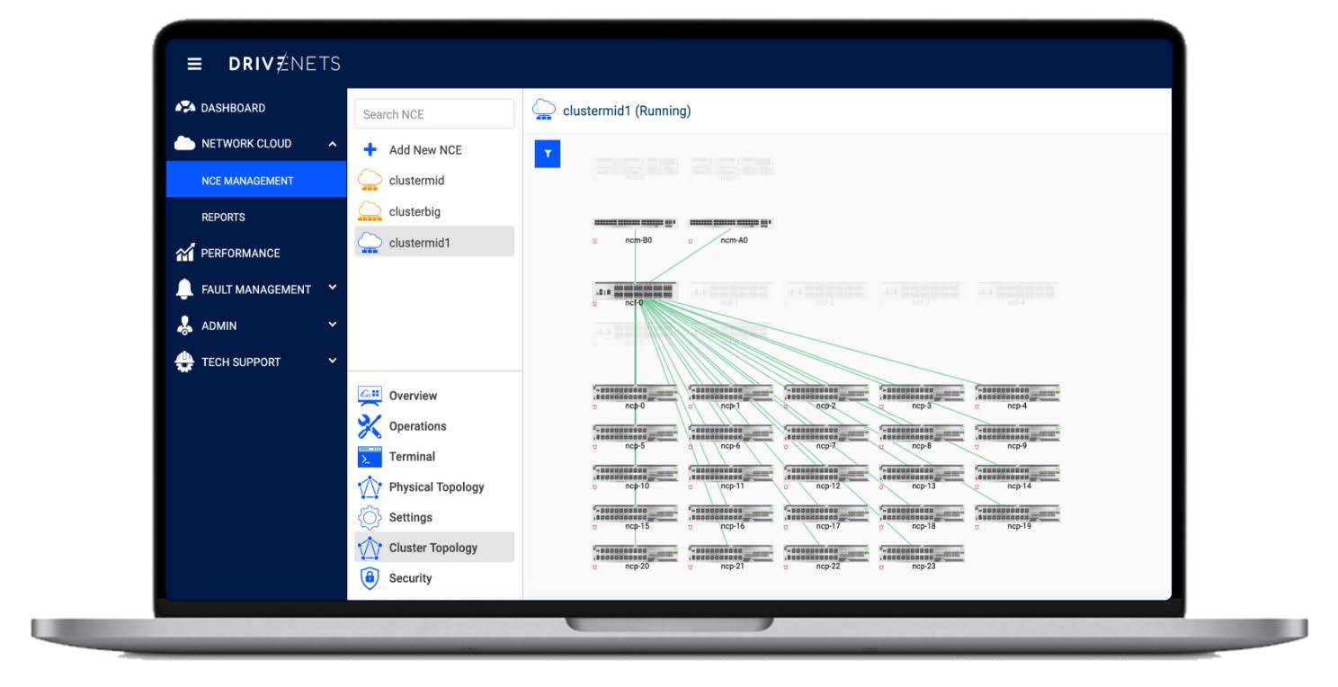

*DNOR's Cluster Topology View*

As a result, service providers can enjoy both centralized network management, which relieves the complexity of managing a distributed disaggregated solution, and deeper network monitoring (per white box), which improves root-cause analysis.

# Are other vendors' legacy networking equipment compatible with DriveNets?

In a word, yes. Established in 2015 with known competitors, DriveNets understood that interoperability was essential to success, especially with all the incumbents in the networking market. Furthermore, DriveNets solutions have been deployed at several service providers and carriers worldwide as a second (and sometimes third) vendor, allowing the closing of any integration gaps. Lastly, the DriveNets support team is well-equipped to resolve any new integration challenges that may arise.

# How does DriveNets manage the cable “spaghetti mess”?

As originally said by Voltaire and later echoed by Peter Parker’s Uncle Ben, "with great power comes great responsibility" also rings true here. With great new flexibility and agility comes great responsibility – namely cable management.

Cable management is imperative for any rack, not just for disaggregated clusters. In order to accommodate maximum density and avoid the cable “spaghetti mess,” proactive cable planning is recommended – and it is crucial to stick to the plan. As capacity is added, it is important to keep track of the integrated indicators within DriveNets Network Cloud cluster, which indicate that each connected cable is correctly connected. Additionally, structured cabling solutions should be used, such as overhead or underfloor cable trays or cable dressing between and within racks.

Service providers also should take advantage of new technologies to reduce cable clutter. For instance, if the cluster's NCF uses 400G interfaces, a shift to 800G interfaces later on can significantly reduce the number of cables.

Above it all, DriveNets’ operational service team is here to help with any deployment needs. DriveNets already has deployed network cloud clusters around the world at different service providers and carriers, accumulating the expertise and knowledge required for effectively deploying routers of any size with the appropriate cable management program. DriveNets can support any deployment while considering current and future network requirements.

# What happens if the wrong fiber cable is pulled either accidentally or intentionally?

A DriveNets Network Cloud's cluster is designed with inherent redundancy, where every element (hardware and software) is backed by another. Therefore, the cluster will continue to operate regardless of any pulled cable. Even if a complete fabric box is down the system will continue to operate.

However, if the only port available to a device or a service is removed from the Network Cloud Packet Forwarder (NCP), the specific service or device will lose connectivity, just like with traditional routing solutions. Therefore, the DriveNets team encourages and assists service providers in planning and deploying their network infrastructure so that high availability and redundancy are top priorities – not just in the fabric domain, but also as part of NCP’s design.

# How does DriveNets Network Cloud address future scalability challenges?

Through enhanced flexibility and innovation in network design, DriveNets Network Cloud can support future scalability requirements. Network Cloud separates the different layers of the network stack, including the control plane and data plane. This modular approach makes upgrading and replacing individual components easier without disrupting the entire network.

* **Hardware scalability:** By building the network with clusters of basic white boxes, service providers can scale capacity by simply adding needed resources one white box at a time. Furthermore, scaling is not constrained by traditional chassis limitations (e.g. free slots, power and location), and there is no need for forklift upgrades.
* **Software scalability:** With software the process is even simpler. Any network function can be added by installing software in a new dedicated container over the existing infrastructure. As a result, time to market (TTM) is reduced from months to days.
* **Emerging technologies:** DriveNets Network Cloud was developed from the ground up to provide service providers with a radical and innovative way to build networks. Therefore, emerging technologies can be implemented without being hindered by outdated or inflexible legacy solutions. For example, A new technology, such as an 800GE interface, does not require the existing network cluster to be replaced or discarded. Instead, a new white

box can be added to the existing cluster with 800GE interfaces. Unlike traditional chassisbased network equipment, there is no need for costly service migration or complex forklift upgrades of the old chassis.

DriveNets' ability to support emerging technologies is crucial to maintaining its leadership position and laser focus on innovating and adapting to emerging technologies as quickly as possible.

# Does DriveNets Network Cloud require forklift replacement?

No. DriveNets Network Cloud is designed with inherent redundancy, where every element (hardware and software) is backed-up by another. This allows operators to replace or add any white-box (NCP and NCF), cable or transceiver immediately, without a forklift replacement of an entire chassis.

When operators realize that there is a problem with a traditional router chassis, on the other hand, they don't have any visibility into its proprietary interconnect components. This makes troubleshooting impossible, leading to a forklift replacement.

# How does DriveNets Network Cloud help with physical site planning?

When it comes to physical site planning, network operators face with a built-in compromise. On the one hand, they can choose physical devices that are optimized for immediate capacity requirements, which must then be replaced when capacity is exceeded. On the other hand, they can invest in a large underpopulated box and accept the high cost associated with it. Furthermore, a large and heavy monolithic chassis has centralized heat, weight, and power distribution requirements, necessitating floor reinforcement and special cooling and power solutions even when not fully utilized.

Traditional networking solutions, in general, lack the agility and flexibility to fully utilize the physical sites of service providers. DriveNets Network Cloud, on the other hand, addresses all the key challenges associated with planning a physical site:

* **Scale**

As DriveNets Network Cloud relies on only two standard hardware building blocks (NCP and NCF), network operators can use only two types of white boxes to maintain their entire network. This makes it easier to plan any network function and capacity, and to adapt to site constraints. The incremental scale is also a plus since operators can grow their networks one box at a time instead of using a forklift.

* **Disaggregated and distributed structure**

Without the restrictions of a large chassis, service providers can spread the NCP and NCF white boxes into different racks. When white boxes are distributed across partially populated racks, their weight, heat, and power are distributed more evenly – eliminating the need for floor reinforcements, complicated cooling efforts, and location-based deployment of high-power infrastructure.

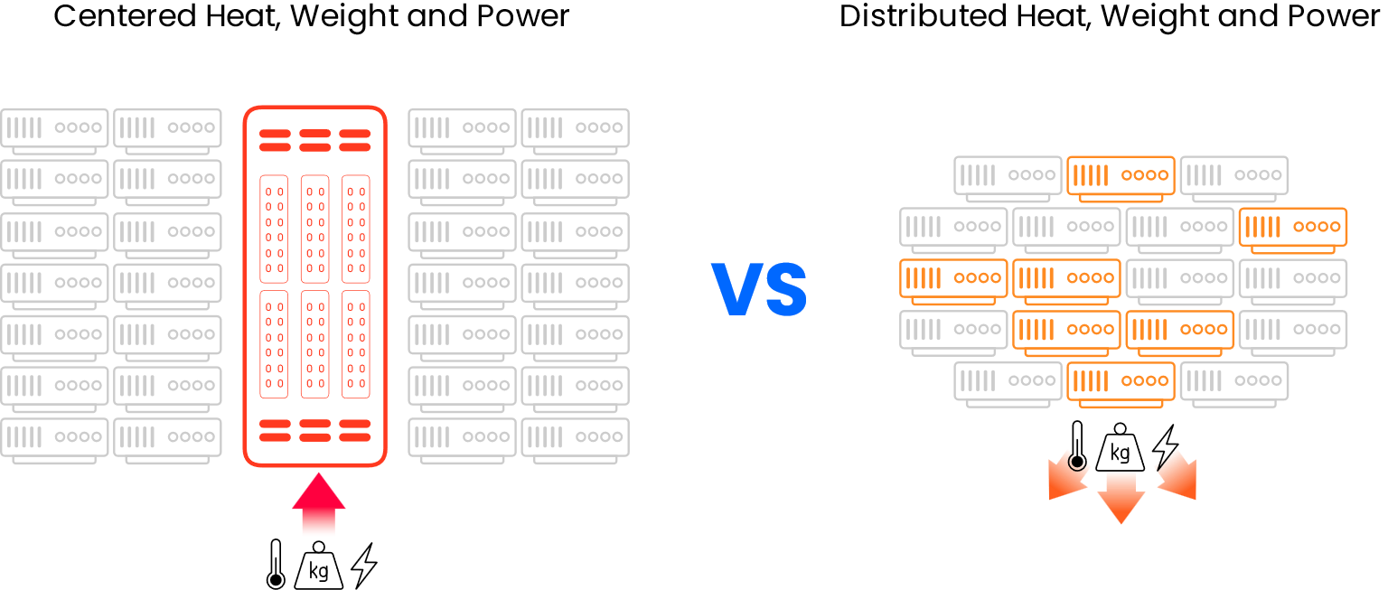

* **Multi-service platform and reuse of available resources**

Network Cloud is not a router per say, but rather a platform that supports routing functionality. As such, it can also run other network functions or be repurposed for different tasks or scales. This allows network operators to run multiple "routers" independently in different containers on a shared resource.

For instance, service providers can run a core router and a peering router as part of a large network cluster that can be scaled incrementally. At the same time, each router can be operated directly through a separate command-line interface (CLI), just like with traditional routers. Additionally, unused white boxes may be used to enhance the scale of another cluster or as stand-alone router.

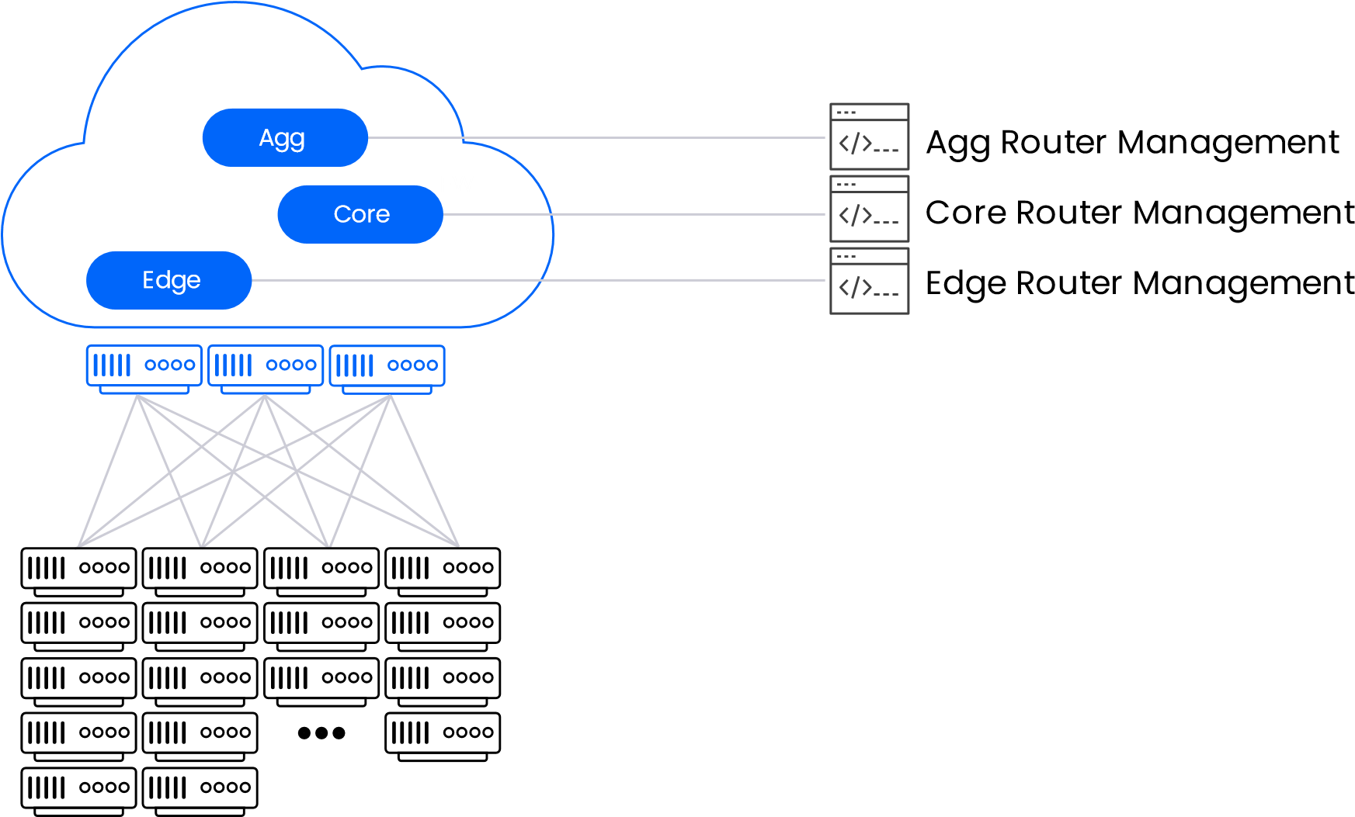

*Each router can be operated directly through a separate command-line interface, but they utilize the same cluster hardware resources.*

These flexible and agile features improve the utilization of existing hardware and minimize the site's physical footprint.

• **Open fabric advantage**

Unlike traditional chassis-based solutions, DriveNets Network Cloud’s physical connectivity consists of interfaces connecting to other Network Cloud elements and other network devices (such as existing legacy equipment).

The lack of a backplane opens the door not only for improved troubleshooting (due to enhanced visibility) but also for tailor-made connectivity for each deployment. For example, external interfaces can be employed by any standard optical transceiver, which can be sourced from any interconnect vendor. Internal connectivity includes low-speed interconnect for the management and control planes of the cluster, and high-speed (400G) interfaces for the data plane fabric (connecting NCP to NCF).

To meet its operational requirements, a service provider can choose between DAC, AOC, AEC, and hybrid deployments:

**DAC (direct attach cable):** While not a valid option for deployments that span beyond a single rack, DAC is the preferred option for small deployments (single rack).

**AOC (active optical cable):** AOC gives the maximum level of deployment flexibility, but its higher total cost is still a factor to consider.

**AEC (active electrical cable):** AEC offers a better price tag for both CapEx and OpEx (power and more) than AOC, as well as a thinner/lighter and easier-to-handle form factor than DAC.

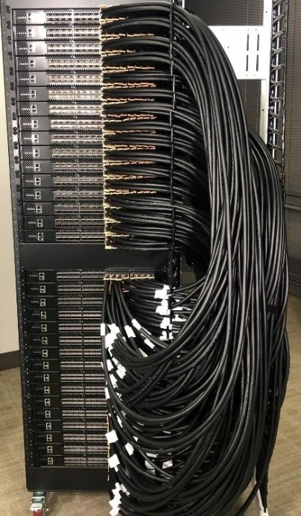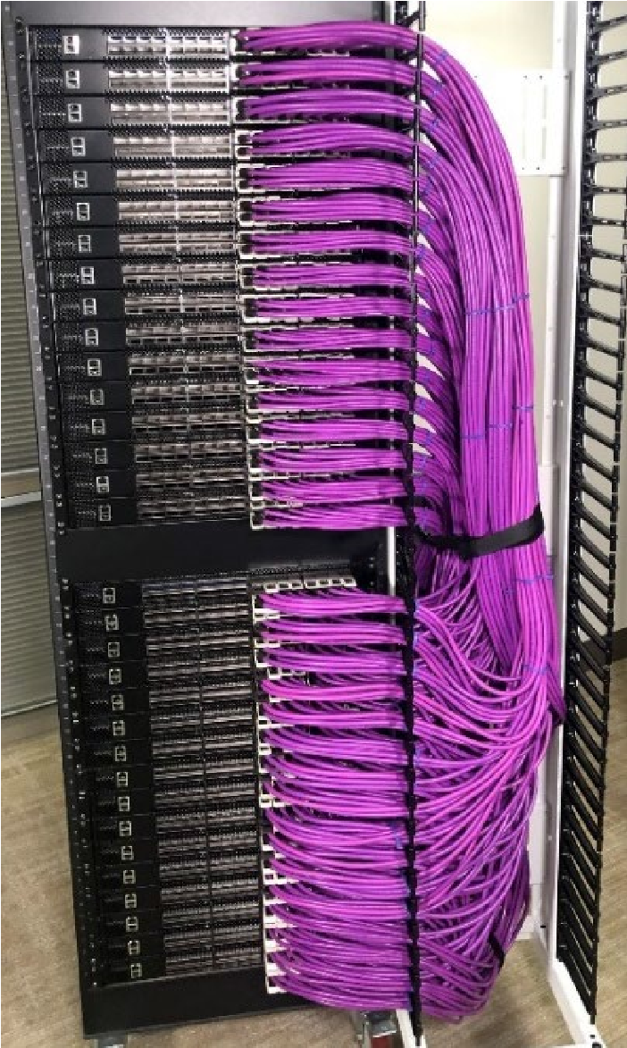

**DAC connectivity:**

•

Lower cost and power

•

Harder to operate due to length

limitations, thickness, large bend

radius, and weight.



**AEC connectivity:**

•

Improved CapEx and OpEx vs.

AOC

•

Easier to operate vs. DAC

# Is it possible to combine 1G-400G and later 800G interfaces in the same router?

Yes. With a DriveNets Network Cloud hybrid cluster, native support for 1G-400G interfaces is possible. In addition, 800G interfaces will soon be available, enabling ultra-flexible clusters running multi-router software (2 independent NOS for 2 different use cases in the same cluster) utilizing any interface from 1G to 800G. For instance, consider a scenario where a core router with 400G and 100G interfaces is operated alongside an edge router with 1G and 10G interfaces. In such a scenario, both routers utilize shared cluster resources yet remain fully autonomous.

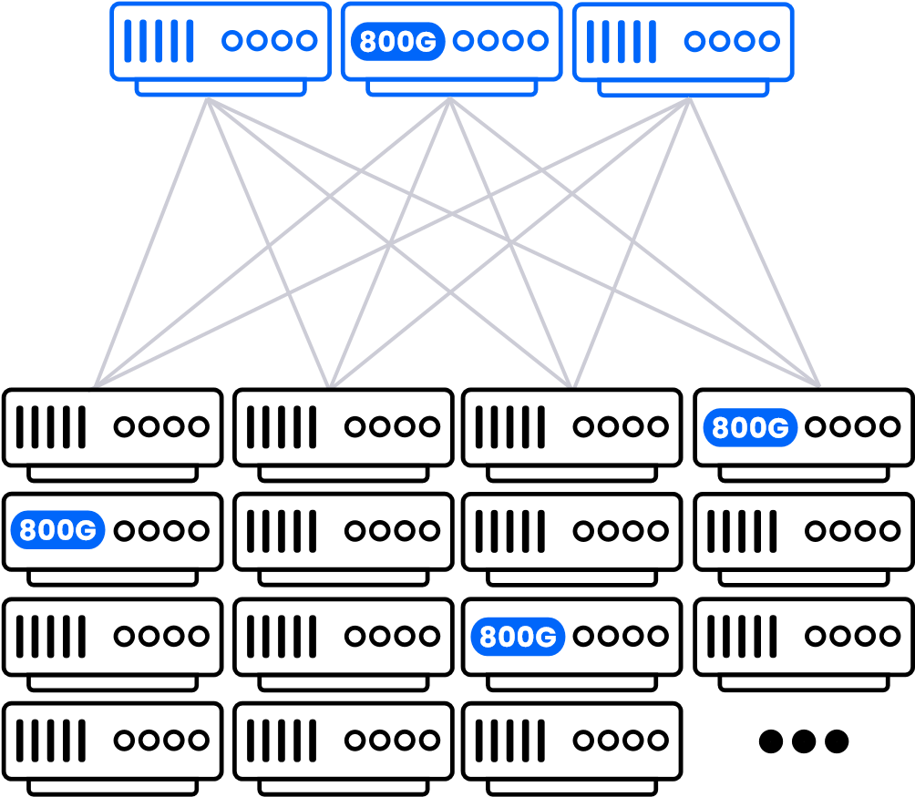Network Cloud Fabric

NCF

NCP

Network Cloud

Packet Forwarder

*Multi-generation cluster*

Additionally, DriveNets can support white boxes from multiple generations. For example, white boxes using different Broadcom ASICs (J2, J2c+, J2c) can be deployed on the same cluster. Currently, DriveNets’ customers require the support of two generations, but this can be changed to meet new requirements if necessary.

# How does DriveNets Network Cloud help simplify the procurement process?

Building a range of chassis routers often requires different proprietary components (ASICs, optics, cables, etc.) per model, leading to high complexity and lead time.

Compared to monolithic routers, DriveNets Network Cloud streamlines procurement by providing:

**Simplified sourcing:** The DriveNets solution only requires six stock-keeping units (SKUs) compared to more than 16 SKUs for a chassis solution. This accelerates project cycle times while simplifying stock and inventory management.

**Standard components:** DriveNets eliminates the need for custom or proprietary rails, power-feed infrastructure, or proprietary optics. With DriveNets Network Cloud, standard components can be easily implemented, providing wide choice and enhanced flexibility in sourcing.

DriveNets is a leader in cloud-native networking software and network disaggregation solutions.

Founded in 2015 and based in Israel, DriveNets offers service providers and cloud providers a radical

new way to build networks, substantially growing their profitability by changing their technological

and economic models. DriveNets’ solution

– Network Cloud – adapts the architectural model of

cloud to telco-grade networking. Network Cloud is a cloud-native software that runs over a shared

physical infrastructure of standard white-boxes, radically simplifying the network’s operations,

offering telco-scale performance and elasticity at a much lower cost.

For more information, visit us at

[www.drivenets.co](http://www.drivenets.com/)

[m](http://www.drivenets.com/)

